
Publication Date 2025
DXL STEEL FRAMING SYSTEMS
PRODUCT DATA SHEET
DOUBLE FURRING CHANNEL
CEILING SYSTEMS
DXL- DFC SERIES    DXL Double Furring Channels are cold-formed galvanized steel profiles used for ceiling suspension and drywall support systems.  DXL 双面副龙骨采用镀锌钢板成型，适用于吊顶悬挂及石膏板支撑系统。  1. PRODUCT INFORMATION / 产品信息  2. DIMENSIONS / 尺寸参数  3. MATERIAL / 材料与表面处理  4. TOLERANCE / 公差标准 | 6.Product Photo / 产品实物  7.SECTIONVIEW / 截面图  8. PACKAGING / 包装示意  Standard bundle packing  category-name printed bag.  Easy for storage and identification
  Product Name 产品名称 | Ceiling Double Furring Channel
  Model No. 型号 | DXL-DFC Series
  Category 类别 | Ceiling Framing System
  Application 应用 | Ceiling suspension and drywall support systems
  Web Width (A) | 50 60
  Thickness (T) | 20 26
  Length | 2800 / 3000 / Custom（≥2000）
  Material材质 | Galvanized steel
  Zinc Coating 镀锌层 | Z100 - Z275 g/m²
  Surface finish 表面处理 | Hot-dip Galvanized
  Thickness 厚度公差 | ±0.03 mm
  Width 宽度公差 | ±0.50 mm
  Length 长度公差 | ±5.0 mm
  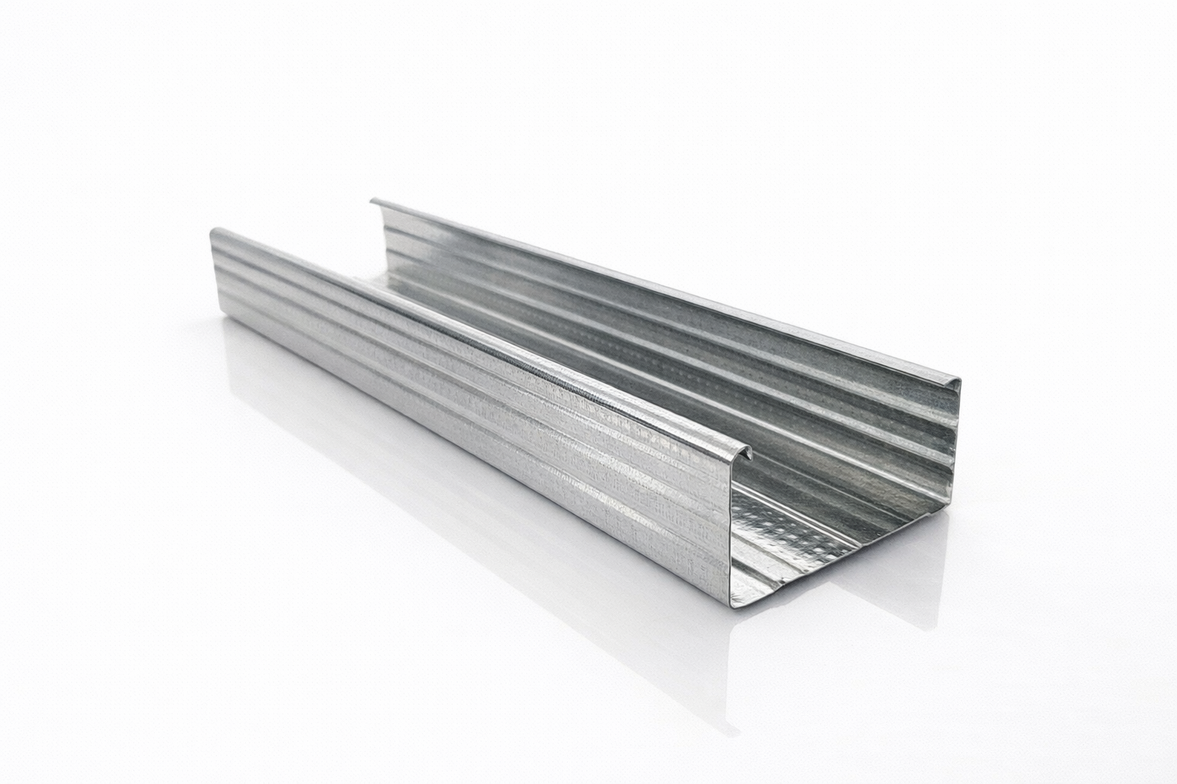
  DXL-WS SERIES
  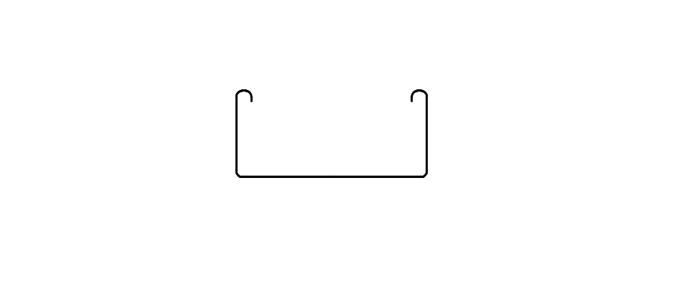
  DXL-WS PROFILE
For Sales Inquiries, please contact our global support team via WhatsApp:＋78764422 or dxlmetal@gmail.com
DXL—Reliable Quality，Global Trust

Specification Table
Model | Web （A）mm | Flange（B）mm | Thickness（T）mm | Length (T) mm
DXL-DFC-50 | 50 | 26 | 0.4 0.5 | 2800 3000 custom（≥2000）
DXL-DFC-60 | 60 | 20 | 0.4.0.5 | 2800 3000 custom（≥2000）
DXL-
DXL-
DXL-

Notes
- Custom length available for all models
- Special dimensions and thickness are available upon request
For Sales Inquiries, please contact our global support team via WhatsApp:＋78764422 or dxlmetal@gmail.com
DXL—Reliable Quality，Global Trust

