
Publication Date 2025
DXL STEEL FRAMING SYSTEMS
PRODUCT DATA SHEET
DRYWALL F-BEAD
DXL- FB SERIES    DXL F-Beads are galvanized steel trim profiles used for drywall edge finishing and board termination details.  DXL F型收边条采用镀锌钢板成型，用于石膏板边缘收口及端部处理。成型，用于非承重隔墙系统。  1. PRODUCT INFORMATION / 产品信息  2. DIMENSIONS / 尺寸参数  3. MATERIAL / 材料与表面处理  4. TOLERANCE / 公差标准 | 6.Product Photo / 产品实物  7.SECTIONVIEW / 截面图  8. PACKAGING / 包装示意  Standard bundle packing  category-name printed bag.  Easy for storage and identification
  Product Name 产品名称 | Drywall F-Bead
  Model No. 型号 | DXL-FB Series
  Category 类别 | Drywall Framing System
  Application 应用 | Drywall edge trim and finishing systems
  Profile Size (A) | Standard＆Custom Sizes
  Thickness (T) | 0.35 0.4 0.45 0.5
  Length | 2800 / 3000 / Custom（≥2000）
  Material材质 | Galvanized steel
  Zinc Coating 镀锌层 | Z100 - Z275 g/m²
  Surface finish 表面处理 | Hot-dip Galvanized
  Thickness 厚度公差 | ±0.03 mm
  Width 宽度公差 | ±0.50 mm
  Length 长度公差 | ±5.0 mm
  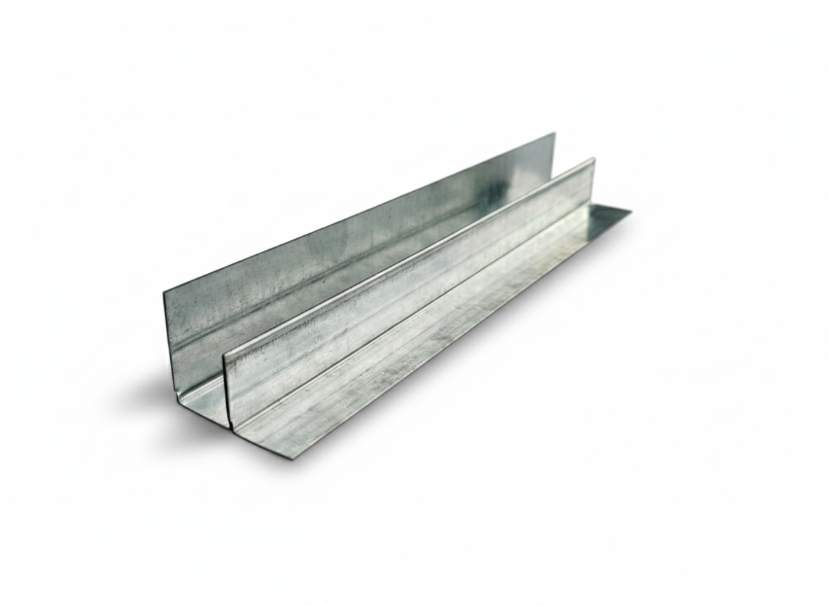
  DXL-WS SERIES
  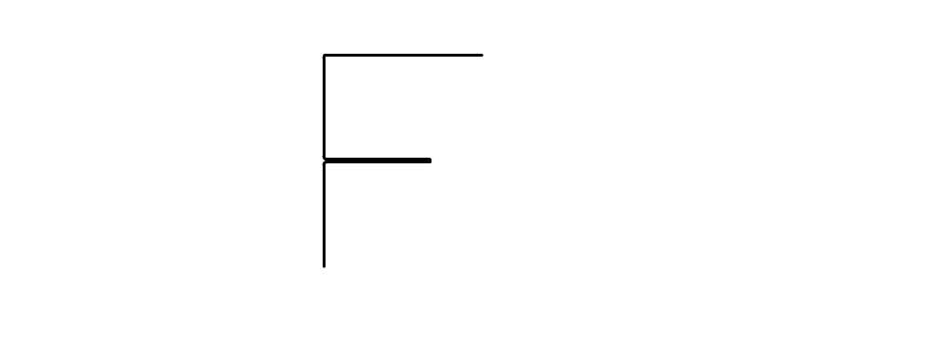
  DXL-WS PROFILE
For Sales Inquiries, please contact our global support team via WhatsApp:＋78764422 or dxlmetal@gmail.com
DXL—Reliable Quality，Global Trust

Specification Table
Model | Vertical Leg | Horizontal Leg | Return Edge | Thickness（T）mm | Length (T) mm
DXL-FB-38 | 38 | 15 | 12 | 0.35 0.4 0.45 0.5 | 2800 3000 custom（≥2000）
DXL-FB-50 | 50 | 20 | 15 | 0.35 0.4 0.45 0.5 | 2800 3000 custom（≥2000）
DXL-FB-90 | 90 | 20 | 30 | 0.35 0.4 0.45 0.5 | 2800 3000 custom（≥2000）
DXL-
DXL-

Notes
- Custom length available for all models
- Special dimensions and thickness are available upon request
For Sales Inquiries, please contact our global support team via WhatsApp:＋78764422 or dxlmetal@gmail.com
DXL—Reliable Quality，Global Trust

