
Publication Date 2025
DXL STEEL FRAMING SYSTEMS
PRODUCT DATA SHEET
HAT CHANNEL

CEILING CHANNEL
DXL Hat Channels are cold-formed galvanized steel furring profiles used in ceiling, wall lining and drywall framing systems  XL- HC SERIES  1. PRODUCT INFORMATION  2. DIMENSIONS  3. MATERIAL  4. TOLERANCE | 6.Product Photo  7.SECTIONVIEW  8. PACKAGING  Standard bundle packing  category-name printed bag.  Easy for storage and identification
  Product Name | Ceiling Hat Channel
  Model No. | DXL-HC Series
  Category | Ceiling Framing System
  Application | Ceiling and wall furring systems
  Profile Size (A) | Standard＆Custom Sizes
  Thickness (T) | 0.40 - 0.60 mm
  Length | 2800 / 3000 / Custom（≥2000）
  Material | Hot-dip Galvanized steel
  Zinc Coating | Z100 - Z275 g/m²
  Surface finish | Galvanized silver-grey finish; custom color powder coating available.
  Thickness | 0/-0.02 mm
  Width | 0/-0.5 mm
  Length | ±1.0 mm
  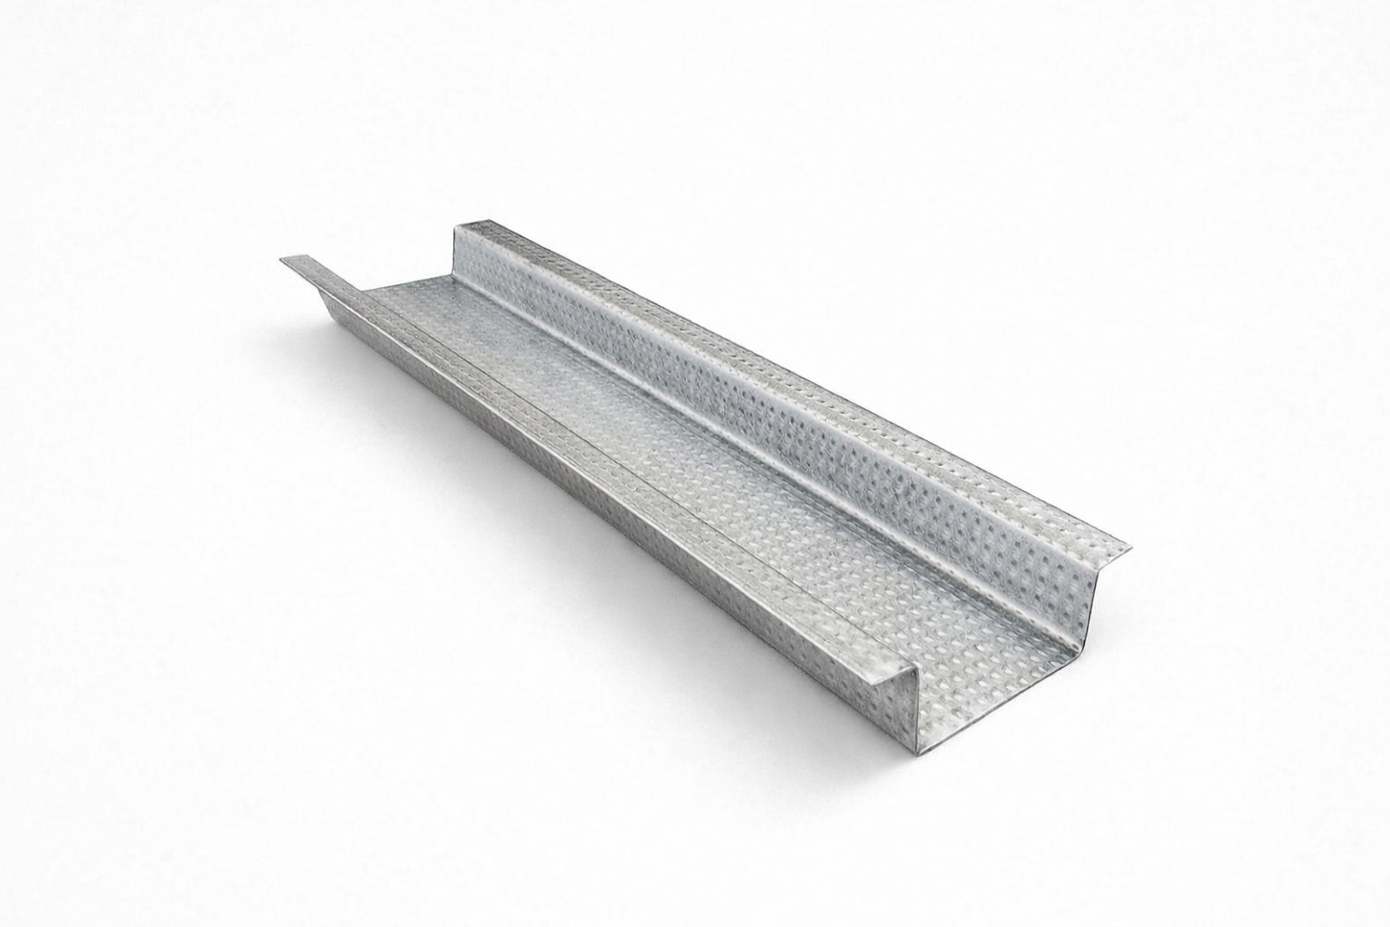
  DXL-WS SERIES
  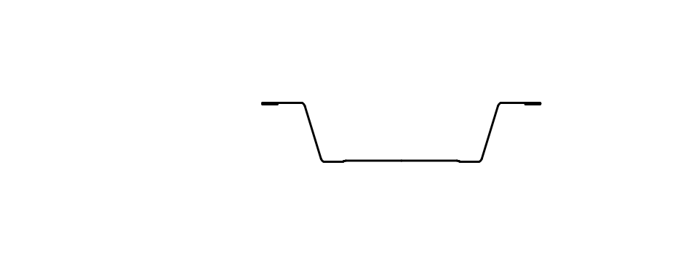
  DXL-WS PROFILE

Specification Table
Model | Overall Width | Top Width | Flange Width | Height | Thickness（mm） | Length (T) mm | Packing
DXL-HC-42 | 42 | 23 | 6 | 7 | 0.40 - 0.60 mm | 2800 3000 custom（≥2000） | As per order confirmation
DXL-HC-50 | 50 | 28 | 7 | 10 | 0.40 - 0.60 mm | 2800 3000 custom（≥2000） | As per order confirmation
DXL-HC-60 | 60 | 35 | 9 | 12 | 0.40 - 0.60 mm | 2800 3000 custom（≥2000） | As per order confirmation

Notes
- Custom length available for all models
- Special dimensions and thickness are available upon request
- Theoretical weight is for reference only. Actual weight shall prevail

