
Publication Date 2025
DXL STEEL FRAMING SYSTEMS
PRODUCT DATA SHEET
HAT CHANNEL
CEILING CHANNEL
DXL- HC SERIES    DXL Hat Channels are cold-formed galvanized steel furring profiles used in ceiling, wall lining and drywall framing systems.  DXL 帽型龙骨采用优质冷轧镀锌钢板成型，适用于吊顶、墙面找平及石膏板基层系统。  1. PRODUCT INFORMATION / 产品信息  2. DIMENSIONS / 尺寸参数  3. MATERIAL / 材料与表面处理  4. TOLERANCE / 公差标准 | 6.Product Photo / 产品实物  7.SECTIONVIEW / 截面图  8. PACKAGING / 包装示意  Standard bundle packing  category-name printed bag.  Easy for storage and identification
  Product Name 产品名称 | Ceiling Hat Channel
  Model No. 型号 | DXL-HC Series
  Category 类别 | Ceiling Framing System
  Application 应用 | Ceiling and wall furring systems
  Profile Size (A) | Standard＆Custom Sizes
  Thickness (T) | 0.4 0.5 0.6
  Length | 2800 / 3000 / Custom（≥2000）
  Material材质 | Galvanized steel
  Zinc Coating 镀锌层 | Z100 - Z275 g/m²
  Surface finish 表面处理 | Hot-dip Galvanized
  Thickness 厚度公差 | ±0.03 mm
  Width 宽度公差 | ±0.50 mm
  Length 长度公差 | ±5.0 mm
  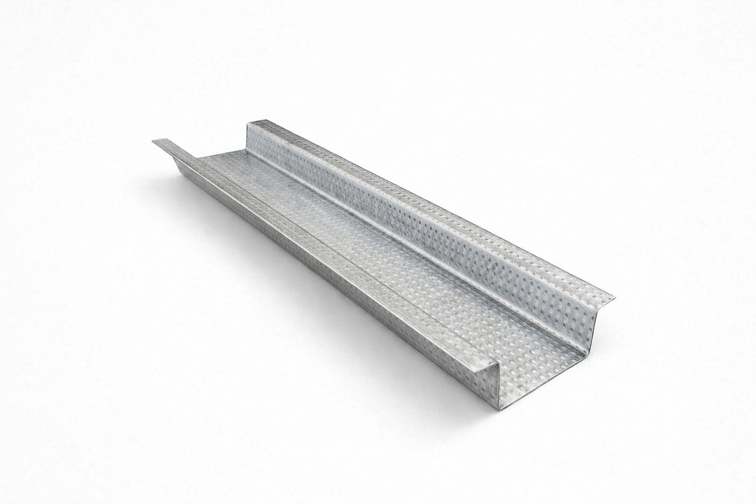
  DXL-WS SERIES
  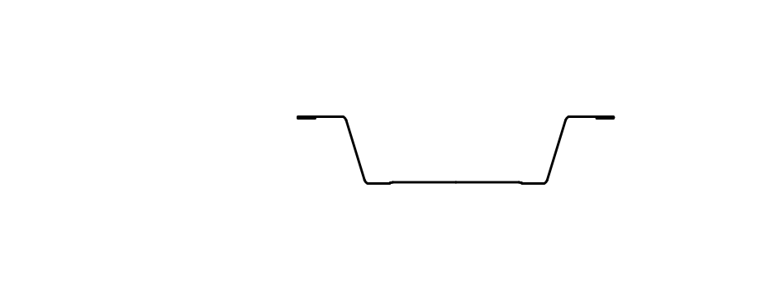
  DXL-WS PROFILE
For Sales Inquiries, please contact our global support team via WhatsApp:＋78764422 or dxlmetal@gmail.com
DXL—Reliable Quality，Global Trust

Specification Table
Model | Overall Width | Top Width | Flange Width | Height | Thickness（mm） | Length (T) mm
DXL-HC-42 | 42 | 23 | 6 | 7 | 0.35 0.4 0.45 0.5 | 2800 3000 custom（≥2000）
DXL-HC-60 | 60 | 35 | 10 | 12 | 0.35 0.4 0.45 0.5 | 2800 3000 custom（≥2000）
DXL-HC-70 | 70 | 34 | 10 | 20 | 0.35 0.4 0.45 0.5 | 2800 3000 custom（≥2000）
DXL-HC-54 | 54 | 38 | 10 | 16 | 0.35 0.4 0.45 0.5 | 2800 3000 custom（≥2000）
DXL-

Notes
- Custom length available for all models
- Special dimensions and thickness are available upon request
For Sales Inquiries, please contact our global support team via WhatsApp:＋78764422 or dxlmetal@gmail.com
DXL—Reliable Quality，Global Trust

