
Publication Date 2025
DXL STEEL FRAMING SYSTEMS
PRODUCT DATA SHEET

DRYWALL J-BEAD
XL- JB SERIES  DXL J-Beads are galvanized steel edge trim profiles used to finish and protect exposed drywall board edges.  1. PRODUCT INFORMATION  2. DIMENSIONS  3. MATERIAL  4. TOLERANCE | 6.Product Photo  7.SECTIONVIEW  8. PACKAGING  Standard bundle packing  category-name printed bag.  Easy for storage and identification
  Product Name | Drywall F-Bead
  Model No. | DXL-JB Series
  Category | Drywall Framing System
  Application | Drywall edge finishing and termination
  Profile Size (A) | Standard＆Custom Sizes
  Thickness (T) | 0.35 - 0.50 mm
  Length | 2800 / 3000 / Custom（≥2000）
  Material | Hot-dip Galvanized steel
  Zinc Coating | Z100 - Z275 g/m²
  Surface finish | Galvanized silver-grey finish; custom color powder coating available.
  Thickness | 0/-0.02 mm
  Width | 0/-0.5 mm
  Length | ±1.0 mm
  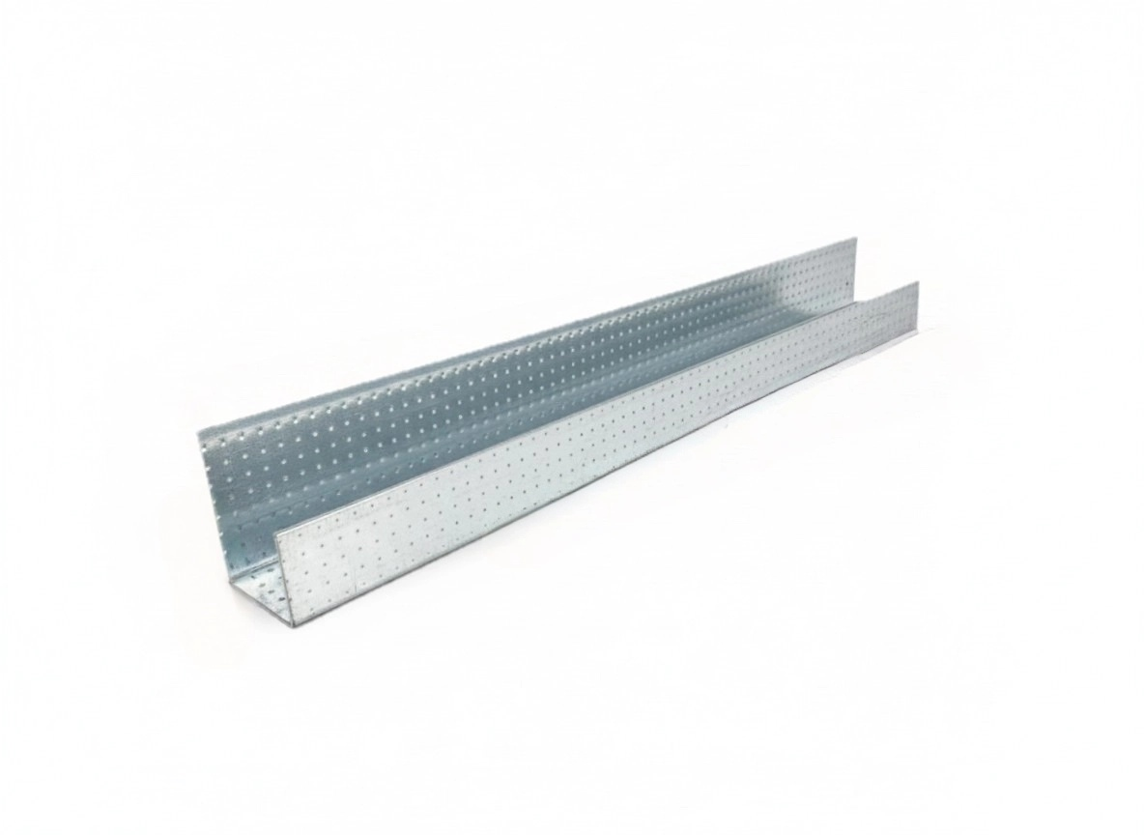
  DXL-WS SERIES
  
  DXL-WS PROFILE

Specification Table
Model | Vertical Leg | Horizontal Leg | Return Edge | Thickness（T）mm | Length (T) mm | Packing
DXL-JB-27-20-20 | 27 | 20 | 20 | 0.35 - 0.50 mm | 2800 3000 custom（≥2000） | As per order confirmation
DXL-JB-30-21 | 30 | 21 | 21 | 0.35 - 0.50 mm | 2800 3000 custom（≥2000） | As per order confirmation
DXL-JB-27-20-12 | 27 | 20 | 17 | 0.35 - 0.50 mm | 2800 3000 custom（≥2000） | As per order confirmation

Notes
- Custom length available for all models
- Special dimensions and thickness are available upon request
- Theoretical weight is for reference only. Actual weight shall prevail

