
Publication Date 2025
DXL STEEL FRAMING SYSTEMS
PRODUCT DATA SHEET

DRYWALL J-BEAD
DXL- JB SERIES  DXL J-Beads are galvanized steel edge trim profiles used to finish and protect exposed drywall board edges.  DXL J型收边条采用镀锌钢板成型，用于石膏板外露边缘的收口与保护。  1. PRODUCT INFORMATION / 产品信息  2. DIMENSIONS / 尺寸参数  3. MATERIAL / 材料与表面处理  4. TOLERANCE / 公差标准 | 6.Product Photo / 产品实物  7.SECTIONVIEW / 截面图  8. PACKAGING / 包装示意  Standard bundle packing  category-name printed bag.  Easy for storage and identification
  Product Name 产品名称 | Drywall F-Bead
  Model No. 型号 | DXL-JB Series
  Category 类别 | Drywall Framing System
  Application 应用 | Drywall edge finishing and termination
  Profile Size (A) | Standard＆Custom Sizes
  Thickness (T) | 0.35 0.4 0.45 0.5
  Length | 2800 / 3000 / Custom（≥2000）
  Material材质 | Galvanized steel
  Zinc Coating 镀锌层 | Z100 - Z275 g/m²
  Surface finish 表面处理 | Hot-dip Galvanized
  Thickness 厚度公差 | ±0.03 mm
  Width 宽度公差 | ±0.50 mm
  Length 长度公差 | ±5.0 mm
  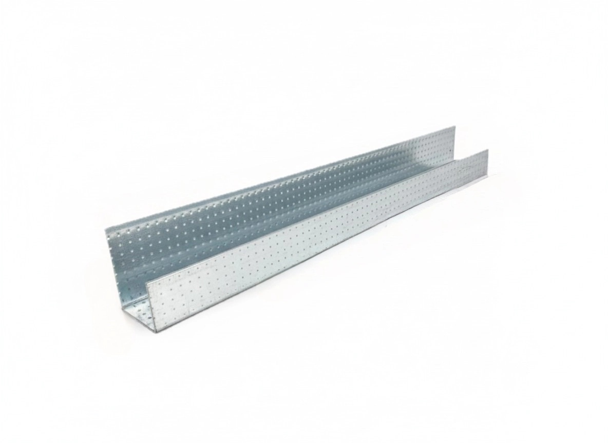
  DXL-WS SERIES
  
  DXL-WS PROFILE

For Sales Inquiries, please contact our global support team via WhatsApp:＋78764422 or dxlmetal@gmail.com
DXL—Reliable Quality，Global Trust

Specification Table
Model | Vertical Leg | Horizontal Leg | Return Edge | Thickness（T）mm | Length (T) mm
DXL-JB-27-20-20 | 27 | 20 | 20 | 0.35 0.4 0.45 05 | 2800 3000 custom（≥2000）
DXL-JB-30-21 | 30 | 21 | 21 | 0.35 0.4 0.45 05 | 2800 3000 custom（≥2000）
DXL-JB-27-20-12 | 27 | 20 | 17 | 0.35 0.4 0.45 05 | 2800 3000 custom（≥2000）
DXL-JB-40-25 | 40 | 25 | 30 | 0.35 0.4 0.45 05 | 2800 3000 custom（≥2000）
DXL-

Notes
- Custom length available for all models
- Special dimensions and thickness are available upon request
For Sales Inquiries, please contact our global support team via WhatsApp:＋78764422 or dxlmetal@gmail.com
DXL—Reliable Quality，Global Trust

