
Publication Date 2025
DXL STEEL FRAMING SYSTEMS
PRODUCT DATA SHEET
L-WALL ANGLE
CELING SYSTEMS
DXL L-Wall Angles are galvanized steel angle profiles used for wall perimeter support and ceiling edge fixing.  DXL- LWA SERIES    1. PRODUCT INFORMATION  2. DIMENSIONS  3. MATERIAL  4. TOLERANCE | 6.Product Photo  7.SECTIONVIEW  8. PACKAGING  Standard bundle packing  category-name printed bag.  Easy for storage and identification
  Product Name | Drywall L-Wall Angle
  Model No. | DXL-LWA Series
  Category | Ceiling Framing System
  Application | Ceiling perimeter and wall edge support
  Profile Size (A) | Standard＆Custom Sizes
  Thickness (T) | 0.40 - 0.60 mm
  Length | 2800 / 3000 / Custom（≥2000）
  Material | Hot-dip Galvanized steel
  Zinc Coating | Z100 - Z275 g/m²
  Surface finish | Galvanized silver-grey finish; custom color powder coating available.
  Thickness | 0/-0.02 mm
  Width | 0/-0.5 mm
  Length | ±1.0 mm
  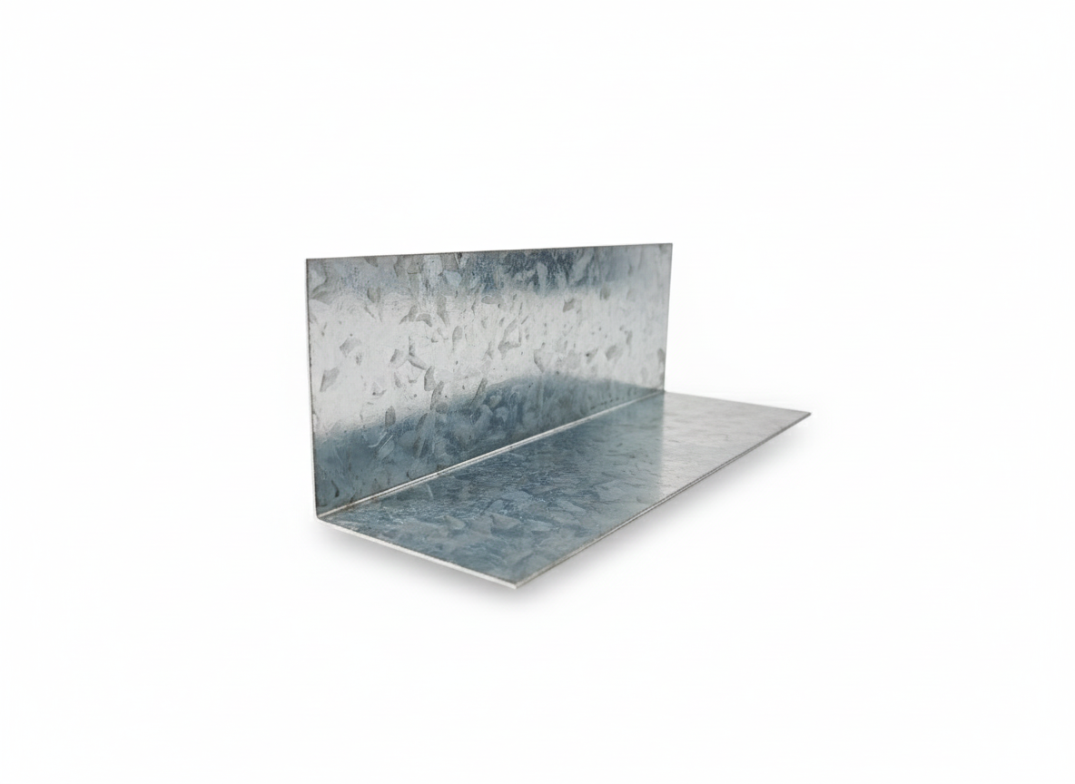
  DXL-WS SERIES
  
  DXL-WS PROFILE

Specification Table
Model | Web （A）mm | Flange（B）mm | Thickness（T）mm | Length (T) mm | Packing
DXL-LWA-20 | 20 | 20 | 0.40 - 0.60 mm | 2800 3000 custom（≥2000） | As per order confirmation
DXL-LWA-30 | 30 | 30 | 0.40 - 0.60 mm | 2800 3000 custom（≥2000） | As per order confirmation
DXL-LWA-30-20 | 30 | 20 | 0.40 - 0.60 mm | 2800 3000 custom（≥2000） | As per order confirmation

Notes
- Custom length available for all models
- Special dimensions and thickness are available upon request
- Theoretical weight is for reference only. Actual weight shall prevail

