
Publication Date 2025
DXL STEEL FRAMING SYSTEMS
PRODUCT DATA SHEET
MAIN CHANNEL
CEILING CHANNEL
.  DXL- MC SERIES  DXL Main Channels are cold-formed galvanized steel sections used as primary support members in suspended ceiling systems    1. PRODUCT INFORMATION  2. DIMENSIONS  3. MATERIAL  4. TOLERANCE | 6.Product Photo  7.SECTIONVIEW  8. PACKAGING  Standard bundle packing  category-name printed bag.  Easy for storage and identification
  Product Name | Ceiling Main Channel
  Model No. | DXL-MC Series
  Category | Ceiling Framing System
  Application | Suspended ceiling support systems
  Web Width (A) | 38 50
  Thickness (T) | 1.0 / 1.2
  Length | 2800 / 3000 / Custom（≥2000）
  Material | Hot-dip Galvanized steel
  Zinc Coating | Z100 - Z275 g/m²
  Surface finish | Galvanized silver-grey finish; custom color powder coating available.
  Thickness | 0/-0.02 mm
  Width | 0/-0.5 mm
  Length | ±1.0 mm
  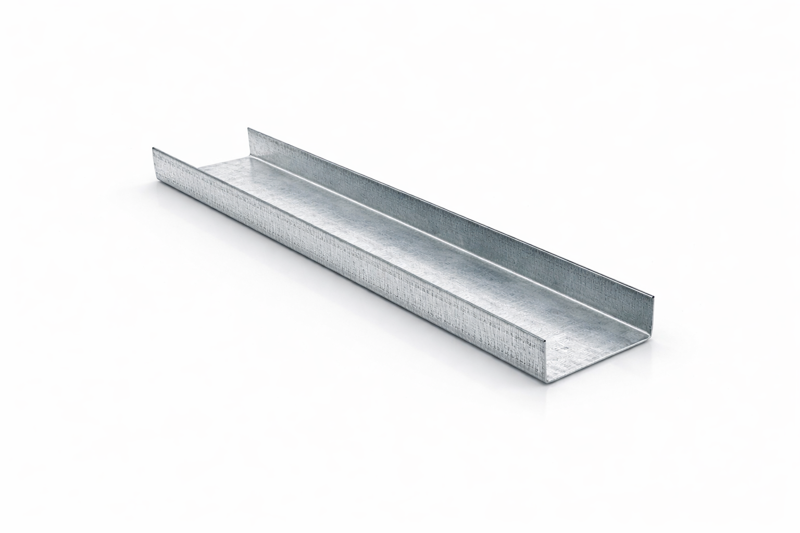
  DXL-WS SERIES
  
  DXL-WS PROFILE

Specification Table
Model | Web （A）mm | Flange（B）mm | Thickness（T）mm | Length (T) mm | Packing
DXL-MC-38 | 38 | 12 | 1.0 / 1.2 | 2800 3000 custom（≥2000） | As per order confirmation
DXL-MC-50 | 50 | 15 | 1.0 / 1.2 | 2800 3000 custom（≥2000） | As per order confirmation

Notes
- Custom length available for all models
- Special dimensions and thickness are available upon request
- Theoretical weight is for reference only. Actual weight shall prevail

