
Publication Date 2025
DXL STEEL FRAMING SYSTEMS
PRODUCT DATA SHEET
SQUARE LEG HAT CHANNEL
CEILING SYSTEMS
DXL- HSC SERIES  DXL Square Leg Hat Channels are galvanized steel furring profiles with straight side legs, used for ceiling and wall framing applications    1. PRODUCT INFORMATION  2. DIMENSIONS  3. MATERIAL  4. TOLERANCE | 6.Product Photo  7.SECTIONVIEW  8. PACKAGING  Standard bundle packing  category-name printed bag.  Easy for storage and identification
  Product Name | Ceiling Square Leg Hat Channel
  Model No. | DXL-HSC Series
  Category | Ceiling Framing Systems
  Application | Ceiling and wall framing systems
  Profile Size (A) | Standard＆Custom Sizes
  Thickness (T) | 0.50 - 0.80 mm
  Length | 2800 / 3000 / Custom（≥2000）
  Material | Hot-dip Galvanized steel
  Zinc Coating | Z100 - Z275 g/m²
  Surface finish | Galvanized silver-grey finish; custom color powder coating available.
  Thickness | 0/-0.02 mm
  Width | 0/-0.5 mm
  Length | ±1.0 mm
  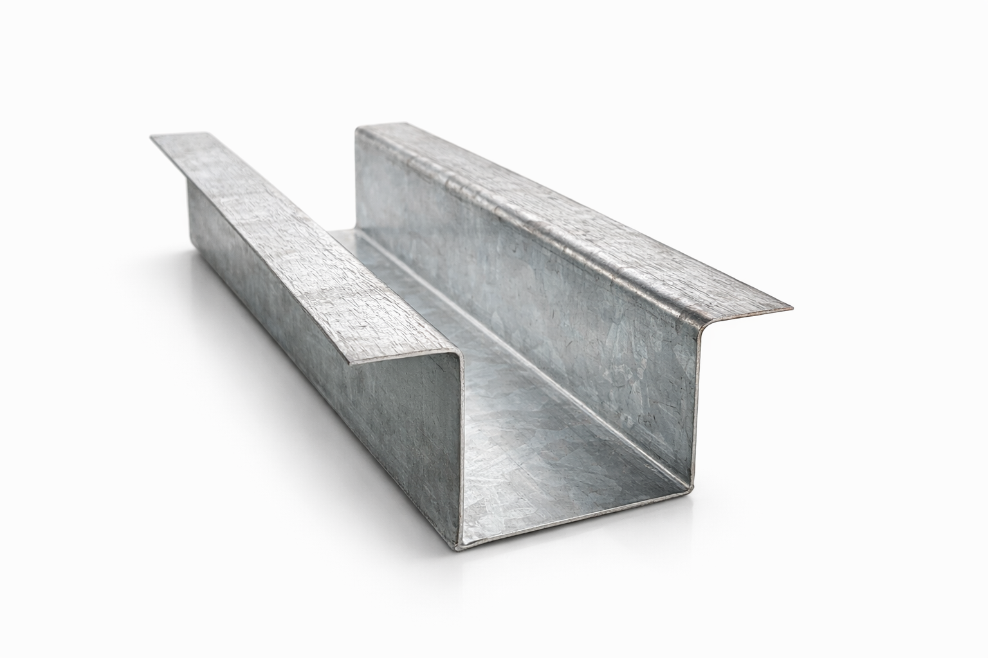
  DXL-WS SERIES
  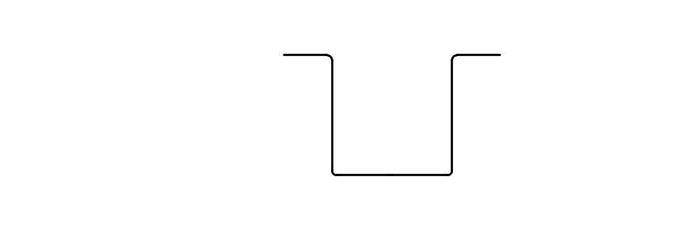
  DXL-WS PROFILE

Specification Table
Model | Overall Width | Top Width | Flange Width | Height | Thickness （mm） | Length (T) mm | Packing
DXL- | 90 | 50 | 20 | 50 | 0.50 - 0.80 mm | 2800 3000 custom（≥2000） | As per order confirmation
DXL- | 52 | 32 | 10 | 16 | 0.50 - 0.80 mm | 2800 3000 custom（≥2000） | As per order confirmation

Notes
- Custom length available for all models
- Special dimensions and thickness are available upon request
- Theoretical weight is for reference only. Actual weight shall prevail

