
Publication Date 2025
DXL STEEL FRAMING SYSTEMS
PRODUCT DATA SHEET

SQUARE LEG HAT CHANNEL
CEILING SYSTEMS
DXL- HSC SERIES  DXL Square Leg Hat Channels are galvanized steel furring profiles with straight side legs, used for ceiling and wall framing applications.  DXL 方腿帽型龙骨采用镀锌钢板成型，两侧为直边结构，适用于吊顶及墙面基层系统。  1. PRODUCT INFORMATION / 产品信息  2. DIMENSIONS / 尺寸参数  3. MATERIAL / 材料与表面处理  4. TOLERANCE / 公差标准 | 6.Product Photo / 产品实物  7.SECTIONVIEW / 截面图  8. PACKAGING / 包装示意  Standard bundle packing  category-name printed bag.  Easy for storage and identification
  Product Name 产品名称 | Ceiling Square Leg Hat Channel
  Model No. 型号 | DXL-HSC Series
  Category 类别 | Ceiling Framing Systems
  Application 应用 | Ceiling and wall framing systems
  Profile Size (A) | Standard＆Custom Sizes
  Thickness (T) | 0.5 0.6 0.7 0.8
  Length | 2800 / 3000 / Custom（≥2000）
  Material材质 | Galvanized steel
  Zinc Coating 镀锌层 | Z100 - Z275 g/m²
  Surface finish 表面处理 | Hot-dip Galvanized
  Thickness 厚度公差 | ±0.03 mm
  Width 宽度公差 | ±0.50 mm
  Length 长度公差 | ±5.0 mm
  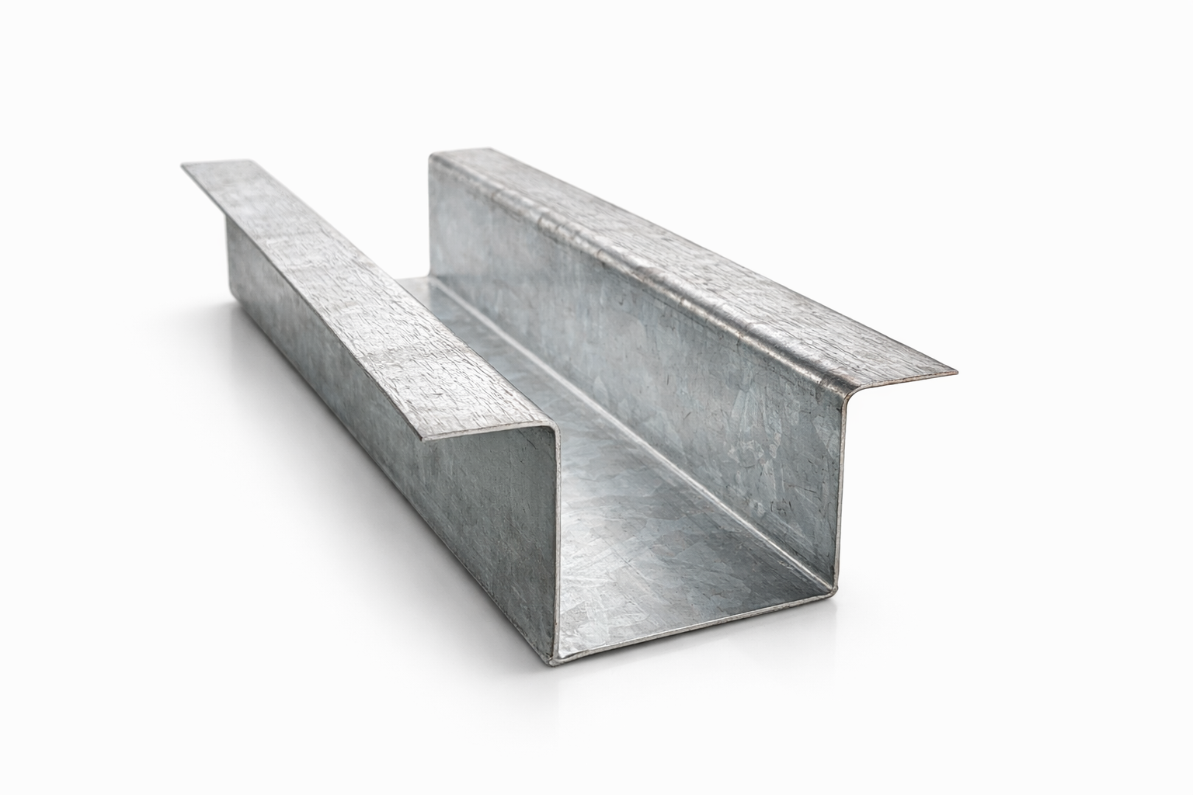
  DXL-WS SERIES
  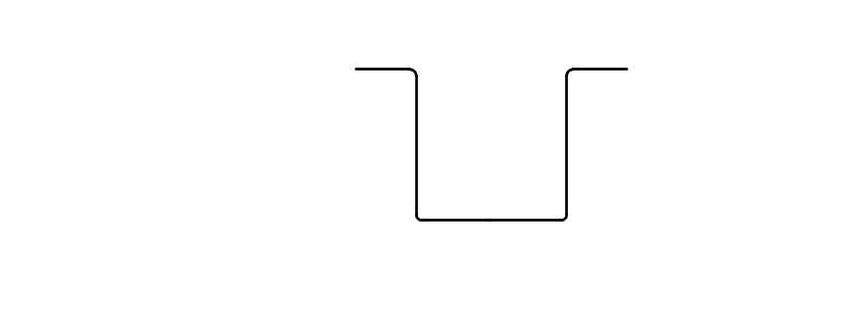
  DXL-WS PROFILE
For Sales Inquiries, please contact our global support team via WhatsApp:＋78764422 or dxlmetal@gmail.com
DXL—Reliable Quality，Global Trust

Specification Table
Model | Overall Width | Top Width | Flange Width | Height | Thickness （mm） | Length (T) mm
DXL- | 90 | 50 | 20 | 50 | 0.5 0.6 0.7 0.8 | 2800 3000 custom（≥2000）
DXL- | 52 | 32 | 10 | 16 | 0.5 0.6 0.7 0.8 | 2800 3000 custom（≥2000）
DXL- |  |  |  |  |  | 2800 3000 custom（≥2000）
DXL- |  |  |  |  |  | 2800 3000 custom（≥2000）
DXL- |  |  |  |  |  | 2800 3000 custom（≥2000）

Notes
- Custom length available for all models
- Special dimensions and thickness are available upon request
For Sales Inquiries, please contact our global support team via WhatsApp:＋78764422 or dxlmetal@gmail.com
DXL—Reliable Quality，Global Trust

