
Publication Date 2025
DXL STEEL FRAMING SYSTEMS
PRODUCT DATA SHEET
DRYWALL STUD
  1. PRODUCT INFORMATION  DXL-WS-SERIES  DXL Drywall Studs are cold-formed steel sections used in non-load bearing drywall framing systems.  2. DIMENSIONS  3. MATERIAL  4. TOLERANCE | 6.Product Photo  7.SECTIONVIEW  8. PACKAGING  Standard bundle packing  category-name printed bag.  Easy for storage and identification
  Product Name | Drywall Stud
  Model No. | DXL-WS Series
  Category | Drywall Framing System
  Application | Interior Partition Walls
  Web Width (A) | 64 73 92 100 150 mm
  Thickness (T) | 0.40 - 0.60 mm
  Length | 2800 / 3000 / Custom（≥2000）
  Material | Hot-dip Galvanized steel
  Zinc Coating | Z100 - Z275 g/m²
  Surface finish | Galvanized silver-grey finish; custom color powder coating available.
  Thickness | 0/-0.02 mm
  Width | 0/-0.5 mm
  Length | ±1.0 mm
  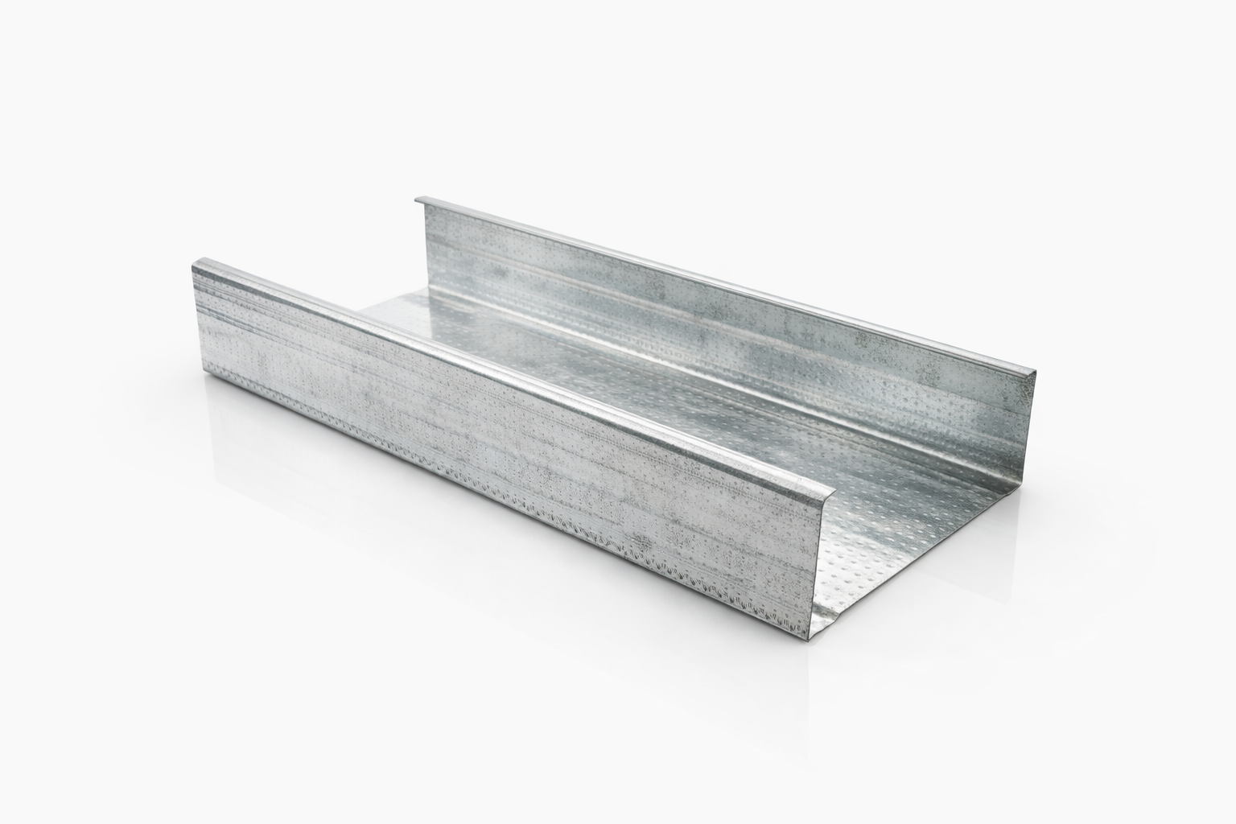
  DXL-WS SERIES
  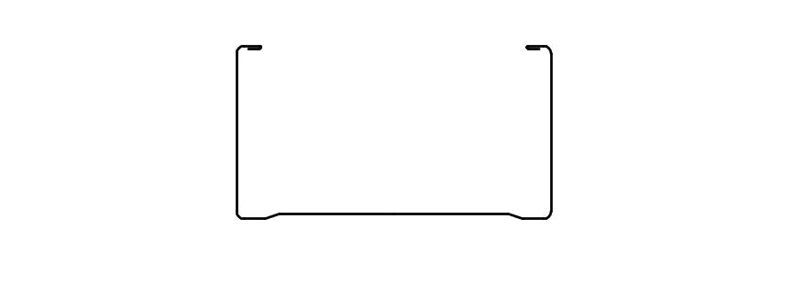
  DXL-WS PROFILE

Specification Table
Model | Web （A）mm | Flange（B）mm | Thickness（T）mm | Length (L)  mm | Packing
DXL-WS64 | 64 | 35 | 0.40 - 0.60 mm | 2800 3000 custom（≥1000） | As per order confirmation
DXL-WS73 | 73 | 32 | 0.40 - 0.60 mm | 2800 3000 custom（≥1000） | As per order confirmation
DXL-WS92 | 95 | 35 | 0.40 - 0.60 mm | 2800 3000 custom（≥1000） | As per order confirmation

Notes
- Custom length available for all models
- Special dimensions and thickness are available upon request
- Theoretical weight is for reference only. Actual weight shall prevail

