
Publication Date 2025
DXL STEEL FRAMING SYSTEMS
PRODUCT DATA SHEET
DRYWALL STUD
DXL-WS-SERIES    DXL Drywall Studs are cold-formed steel sections used in non-load bearing drywall framing systems.  DXL 竖向龙骨采用优质冷轧镀锌钢板成型，用于非承重隔墙系统。  1. PRODUCT INFORMATION / 产品信息  2. DIMENSIONS / 尺寸参数  3. MATERIAL / 材料与表面处理  4. TOLERANCE / 公差标准 | 6.Product Photo / 产品实物  7.SECTIONVIEW / 截面图  8. PACKAGING / 包装示意  Standard bundle packing  category-name printed bag.  Easy for storage and identification
  Product Name 产品名称 | Drywall Stud 竖向龙骨
  Model No. 型号 | DXL-WS Series
  Category 类别 | Drywall Framing System
  Application 应用 | Interior Partition Walls
  Web Width (A) | 64 73 92 100 150 mm
  Thickness (T) | 0.4 0.5 0.6 mm
  Length | 2800 / 3000 / Custom（≥2000）
  Material材质 | Galvanized steel
  Zinc Coating 镀锌层 | Z100 - Z275 g/m²
  Surface finish 表面处理 | Hot-dip Galvanized
  Thickness 厚度公差 | ±0.03 mm
  Width 宽度公差 | ±0.50 mm
  Length 长度公差 | ±5.0 mm
  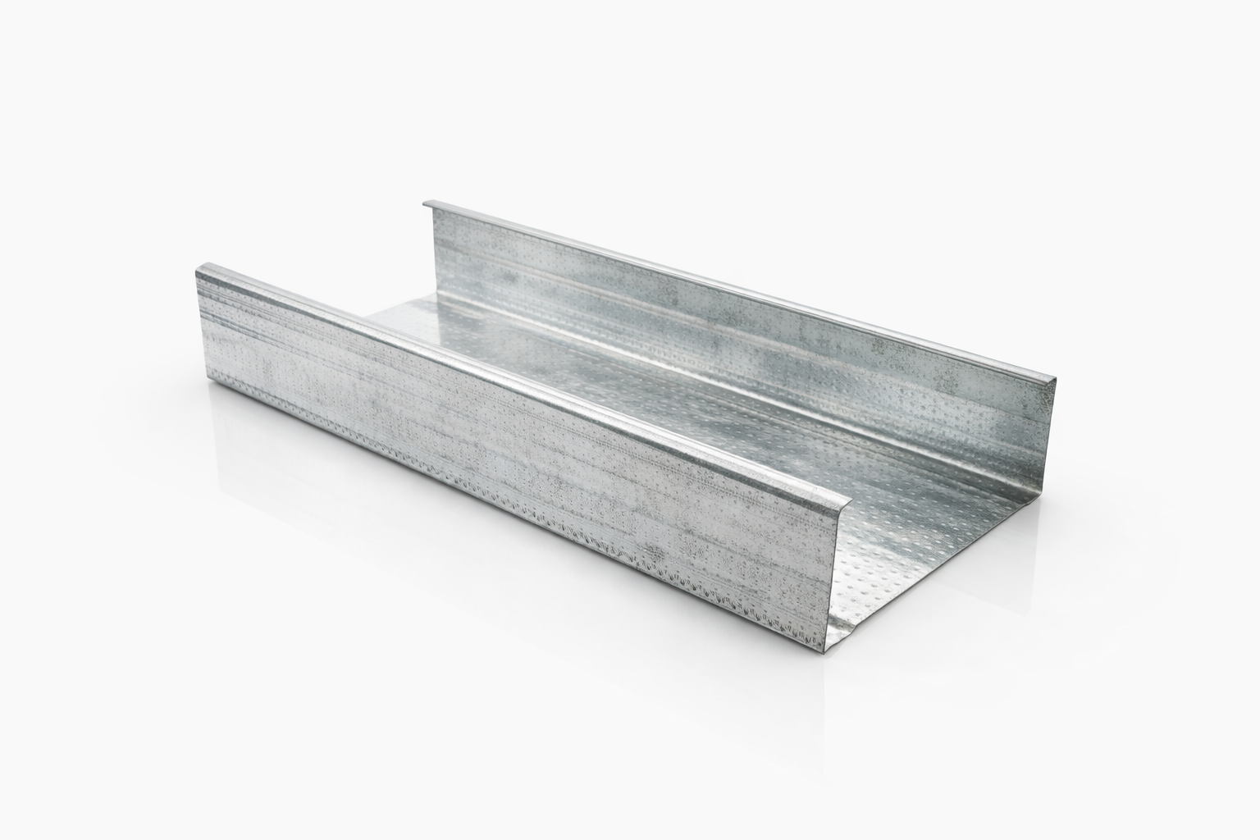
  DXL-WS SERIES
  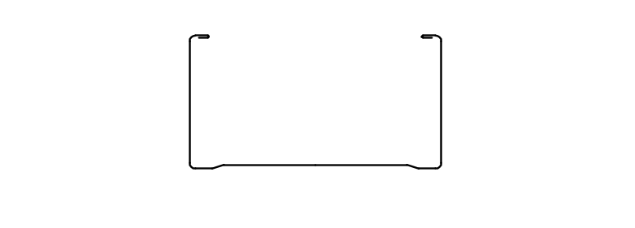
  DXL-WS PROFILE
For Sales Inquiries, please contact our global support team via WhatsApp:＋78764422 or dxlmetal@gmail.com
DXL—Reliable Quality，Global Trust

Specification Table
Model | Web （A）mm | Flange（B）mm | Thickness（T）mm | Length (T) mm
DXL-WS64 | 64 | 35 | 0.4 0.5 0.6 | 2800 3000 custom（≥2000）
DXL-WS73 | 73 | 32 | 0.4 0.5 0.6 | 2800 3000 custom（≥2000）
DXL-WS92 | 95 | 35 | 0.4 0.5 0.6 | 2800 3000 custom（≥2000）
DXL-WS100 | 100 | 45 | 0.4 0.5 0.6 | 2800 3000 custom（≥2000）
DXL-WS150 | 150 | 32 | 0.4 0.5 0.6 | 2800 3000 custom（≥2000）

Notes
- Custom length available for all models
- Special dimensions and thickness are available upon request
For Sales Inquiries, please contact our global support team via WhatsApp:＋78764422 or dxlmetal@gmail.com
DXL—Reliable Quality，Global Trust

