
Publication Date 2025
DXL STEEL FRAMING SYSTEMS
PRODUCT DATA SHEET
DRYWALL TRACK
  DXL-WT-SERIES  DXL Tracks are cold-formed galvanized steel sections used as top and bottom channels in non-load bearing drywall partition systems.  1. PRODUCT INFORMATION  2. DIMENSIONS  3. MATERIAL  4. TOLERANCE | 6.Product Photo  7.SECTIONVIEW  8. PACKAGING  Standard bundle packing  category-name printed bag.  Easy for storage and identification
  Product Name | Drywall Track
  Model No. | Drywall WT Series
  Category | Drywall Framing System
  Application | Partition wall top and bottom track systems
  Web Width (A) | 65 75 94 130
  Thickness (T) | 0.40 - 0.60 mm
  Length | 2800 / 3000 / Custom（≥2000）
  Material | Hot-dip Galvanized steel
  Zinc Coating | Z100 - Z275 g/m²
  Surface finish | Galvanized silver-grey finish; custom color powder coating available.
  Thickness | 0/-0.02 mm
  Width | 0/-0.5 mm
  Length | ±1.0 mm
  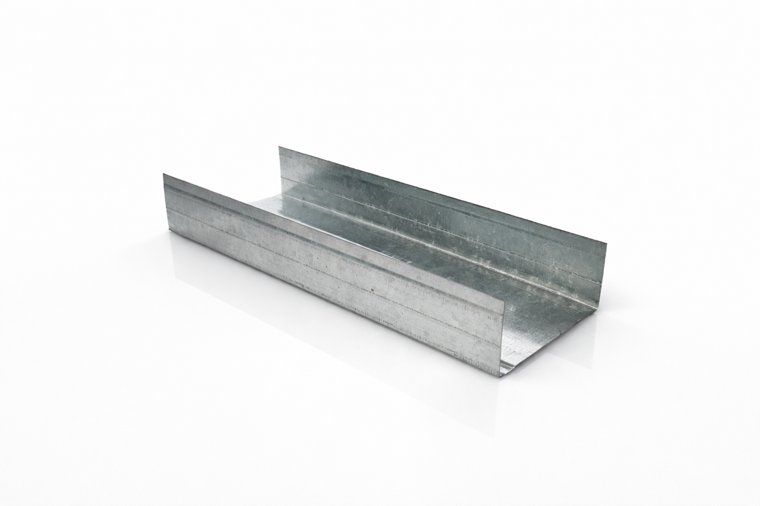
  DXL-WT SERIES
  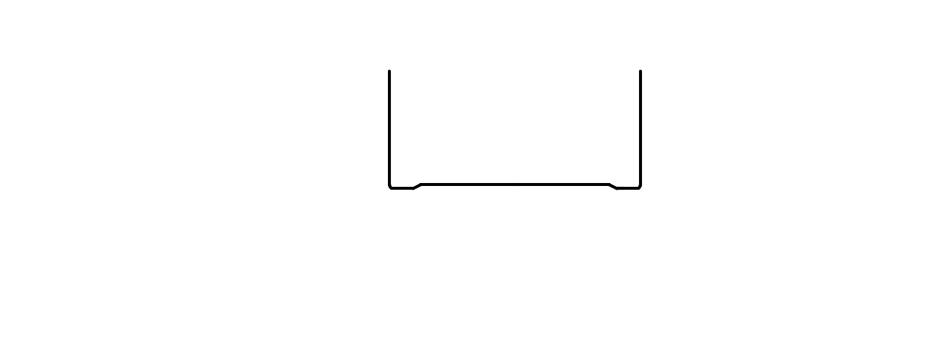
  DXL-WS PROFILE

Specification Table
Model | Web （A）mm | Flange（B）mm | Thickness（T）mm | Length (T) mm | Packing
DXL-WT-65 | 65 | 26 | 0.40 - 0.60 mm | 2800 3000 custom（≥2000） | As per order confirmation
DXL-WT-75 | 75 | 35 | 0.40 - 0.60 mm | 2800 3000 custom（≥2000） | As per order confirmation
DXL-WT-94 | 94 | 32 | 0.40 - 0.60 mm | 2800 3000 custom（≥2000） | As per order confirmation

Notes
- Custom length available for all models
- Special dimensions and thickness are available upon request
- Theoretical weight is for reference only. Actual weight shall prevail

